**MOTOR INSURANCE APPLICATION**

**Scenario**:

The **General Insurance company** wishes to implement an online portal to issue a new business motor policy. They have decided to build an application that will issue a quotation and subsequently the quotation can be converted to a new business policy based on customer acceptance.

**Requirements**:

They have decided to build an application that will:

* Allow users to enter risk details to calculate the price and eligibility for plans. If not eligible for any plan, then Resolve-reject.
* Use a rules engine to determine the most appropriate plan along with other plans for user.
* Allow users to decide if they wish to accept or reject offer. Save the offer based on user acceptance. If not accepted put the case on hold till 30 days. Post 30 days cancel the case (Resolved-Cancel).
* If the quotation is not rejected by auto reject rules or not applicable for UW review then, send the offer quotation as an email to user from personalized email account.
* Check underwriting conditions and refer to underwriter if required Allow the underwriter to review the details entered by the user and manually select one plan for the user. Let the underwriter edit the details.
* Once user accept the quotation (Outside Application), user to enter additional details for converting the quotation to a policy with successful payment.
* Do a de-duplication check with external system and reject the quotation if already present.
* Issue a new business policy once user accepts terms and conditions.
* Allow user to do the payment. Send policy details to user once the payment is successfully completed.

**Actors:**

* Agent – Initiates the new business case and issue the policy.
* Underwriter – Member of the underwriting team to approve/reject referred quotations.
* IT Manager – Can runs reports.
* Application Structure: Framework
* Organization: GIC
* Division: Insurance
* Unit: Vehicle
* Application Name: Motor Insurance

**Work Class:**

GIC-FW-MotorIns-Work

GIC-FW-MotorIns-Work-GetVehicleInsurance

**Data Class:**

GIC-FW-MotorIns-Data

GIC-FW-MotorIns-Data-Car Details

GIC-FW-MotorIns-Data-DriverDetails

GIC-FW-MotorIns-Data-PlanMaster

GIC-FW-MotorIns-Data-PolicyDetails

GIC-FW-MotorIns-Data-ClaimHistory

GIC-FW-MotorIns-Data-YearOfManufacture

**ECS Structure:**

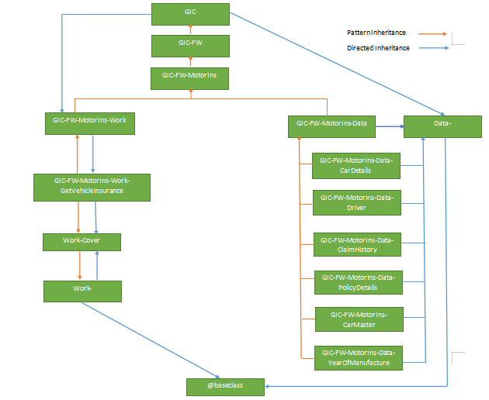

**Sample Users /Operators:**

**Agent:** Agent@GIC

**Underwriter:** Underwriter@GIC

**IT Manager:** Managers@GIC

**Sample Work Groups:**

Underwriter

**Access Groups:**

MotorIns: Underwriter

 MotorIns: Authors

 MotorIns: Agent

 MotorIns: Managers

**Case Life Cycle Design:**

**Motor Insurance:**

**Case lifecycle:**

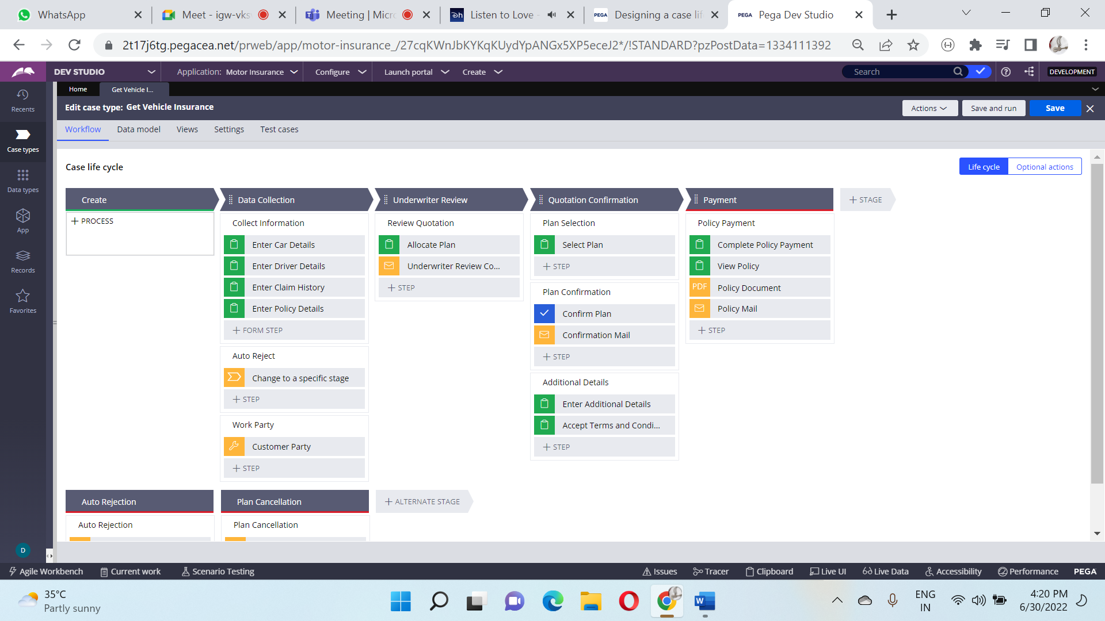

**Alternate Stages:**

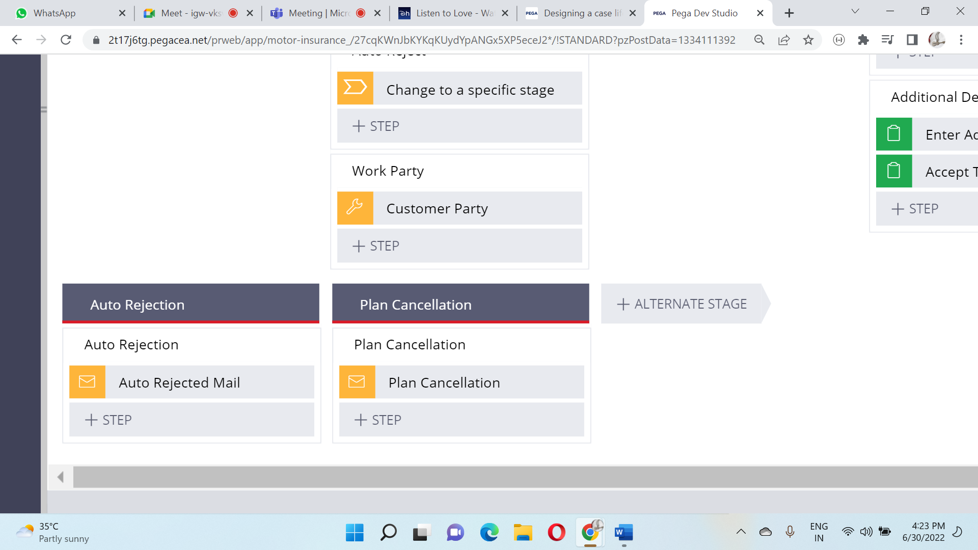

**Data Model Design:**

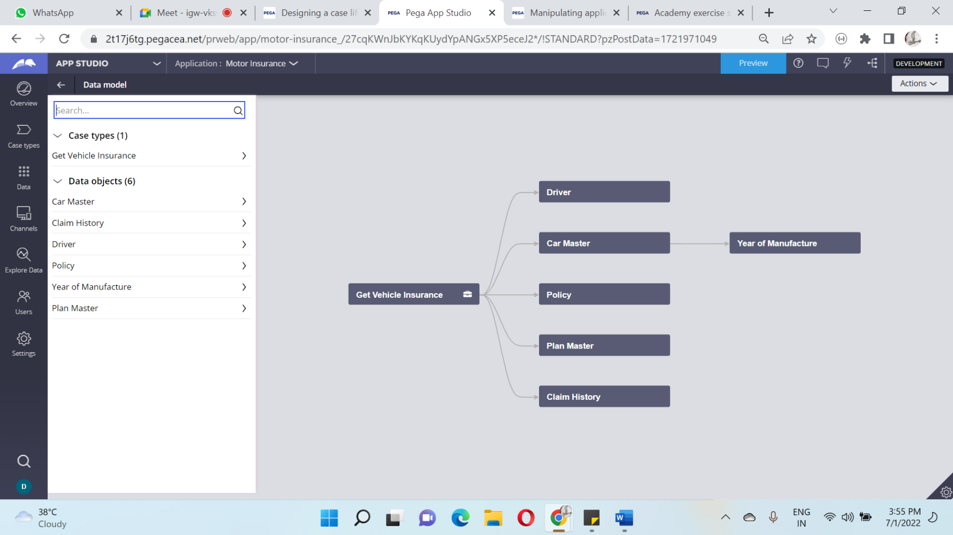

**Process design:**

**Collect Details:**

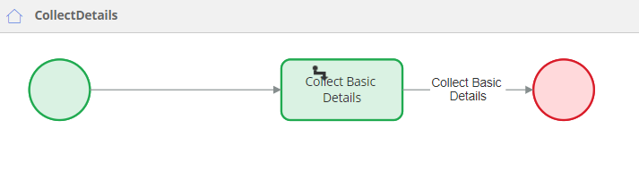

**Check Duplicates:**

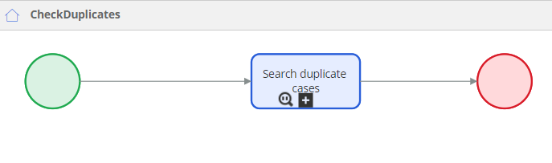

**Collect Information:**

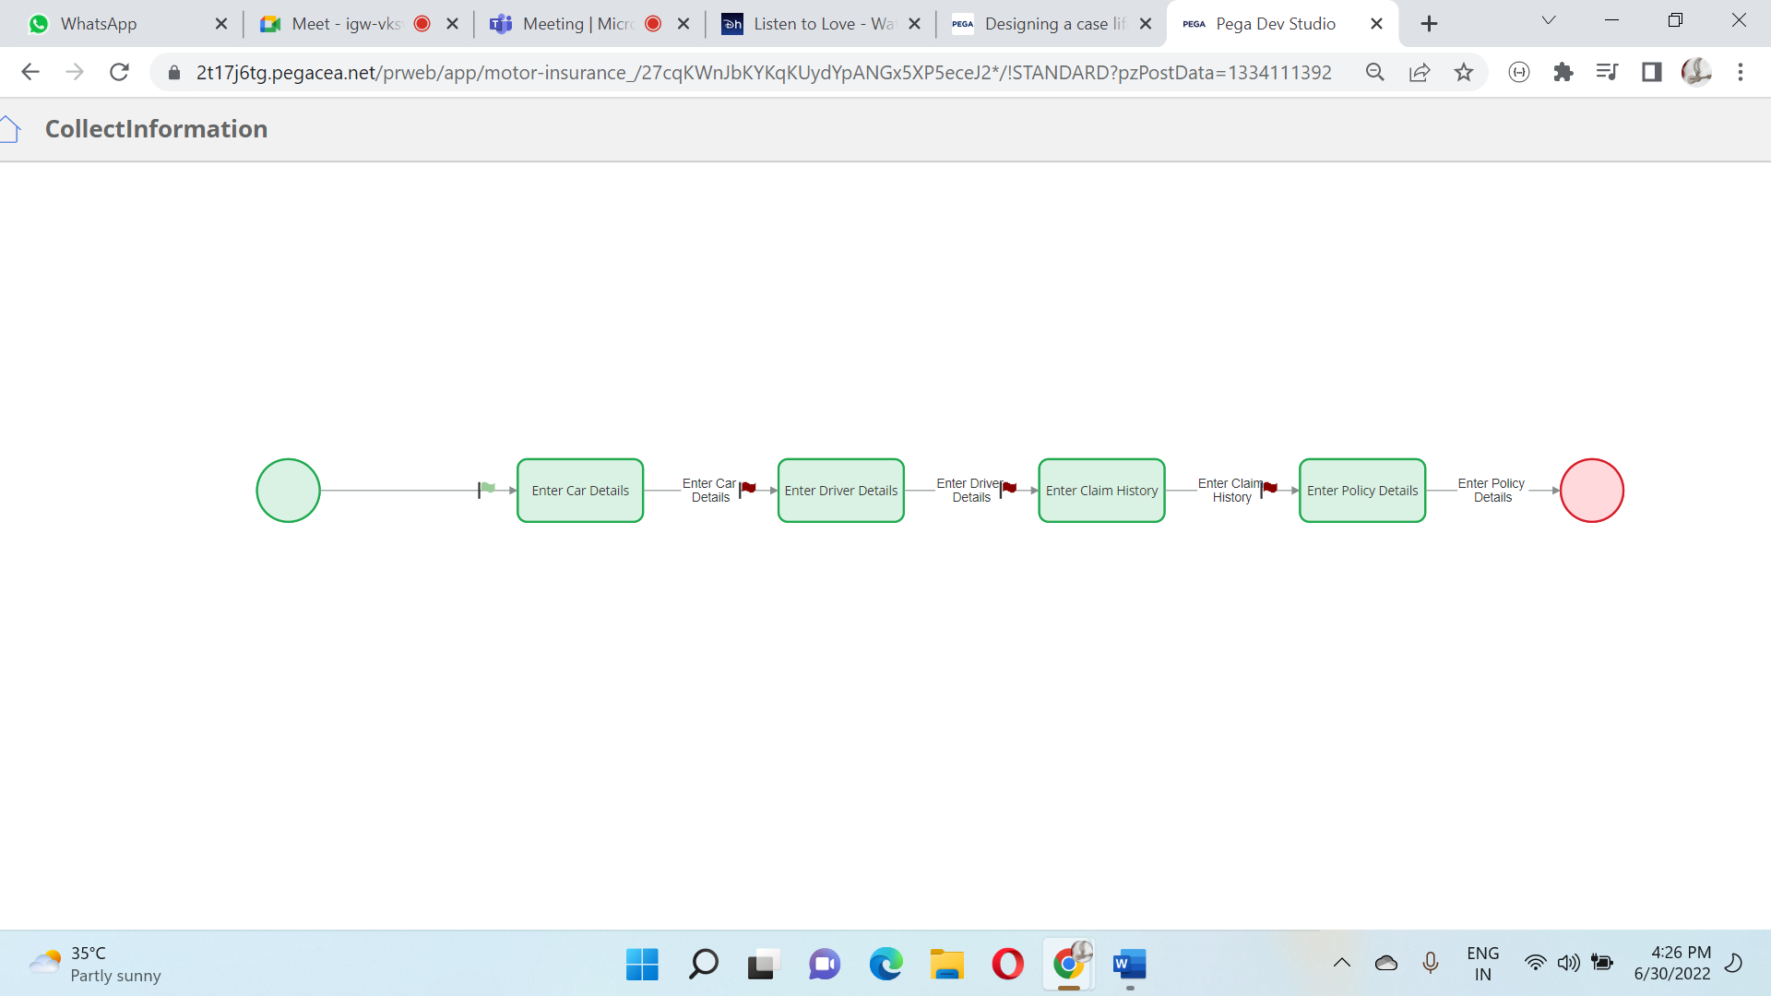

**Create Work Party:**

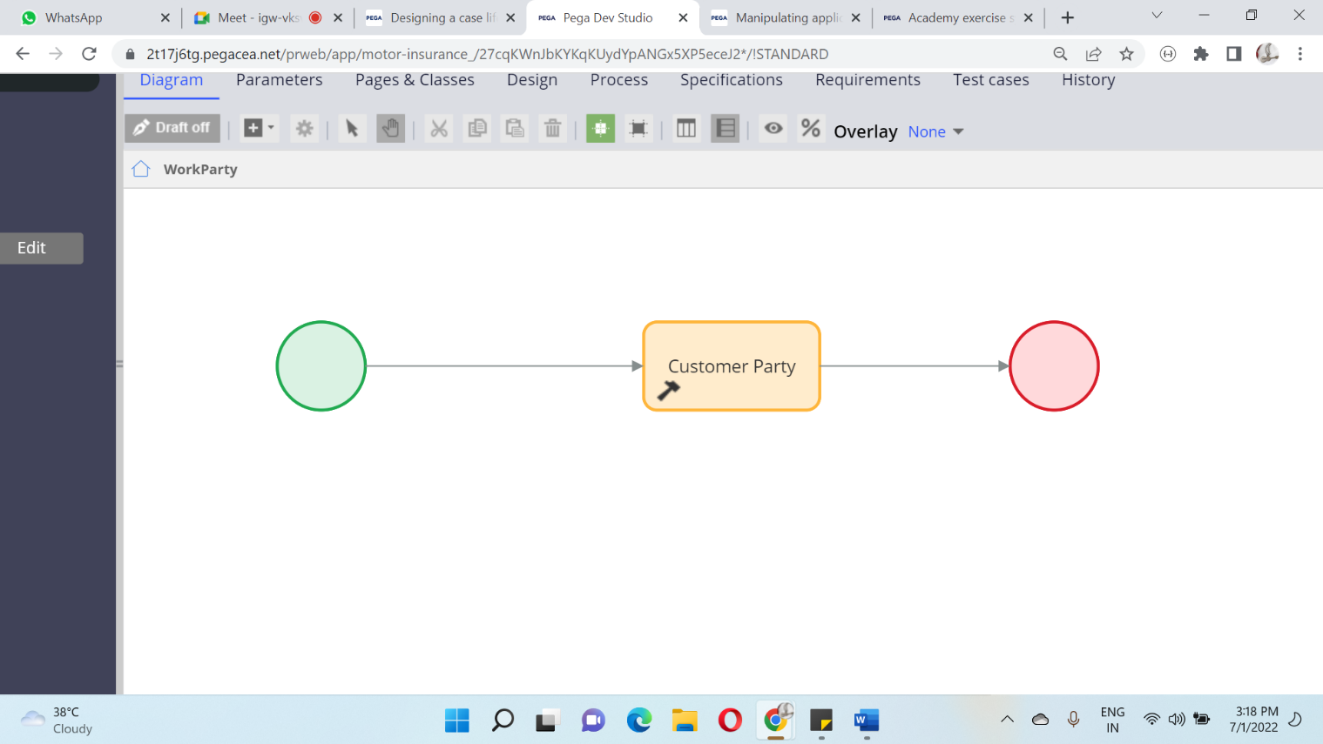

**Auto Rejection:**

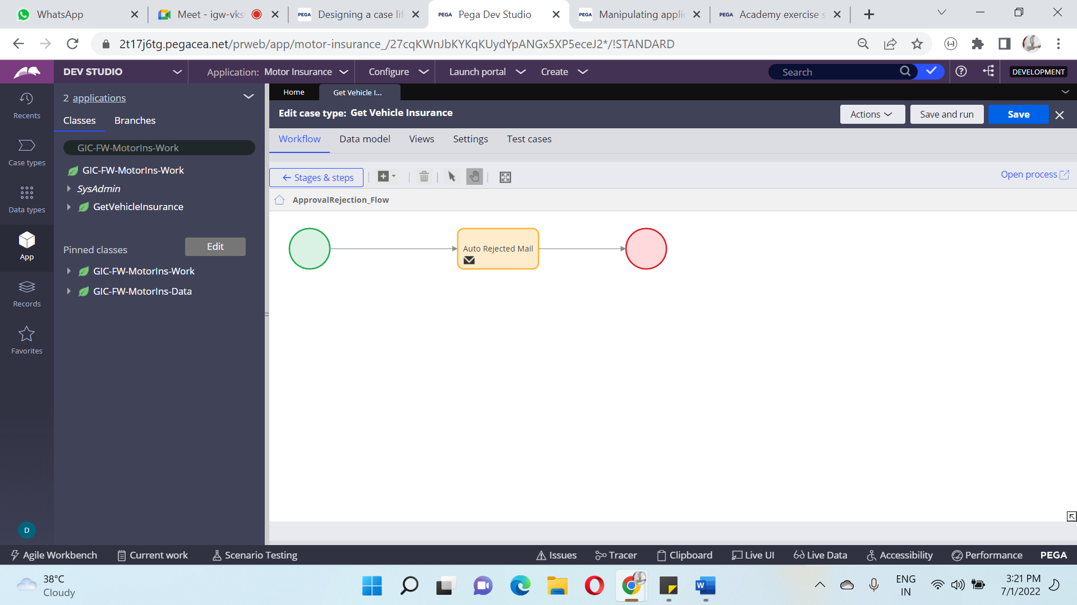

**Review Details:**

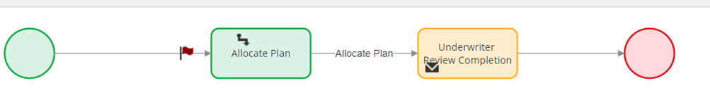

**Plan Selection:**

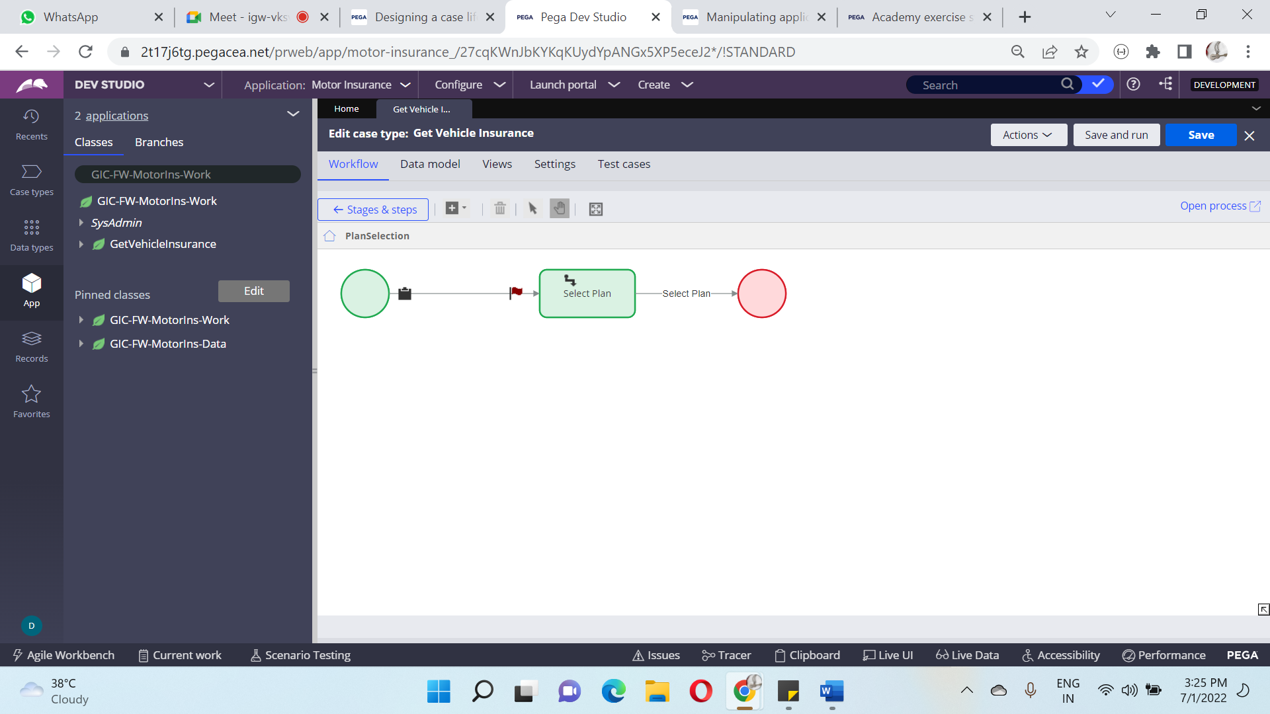

**Plan Confirmation:**

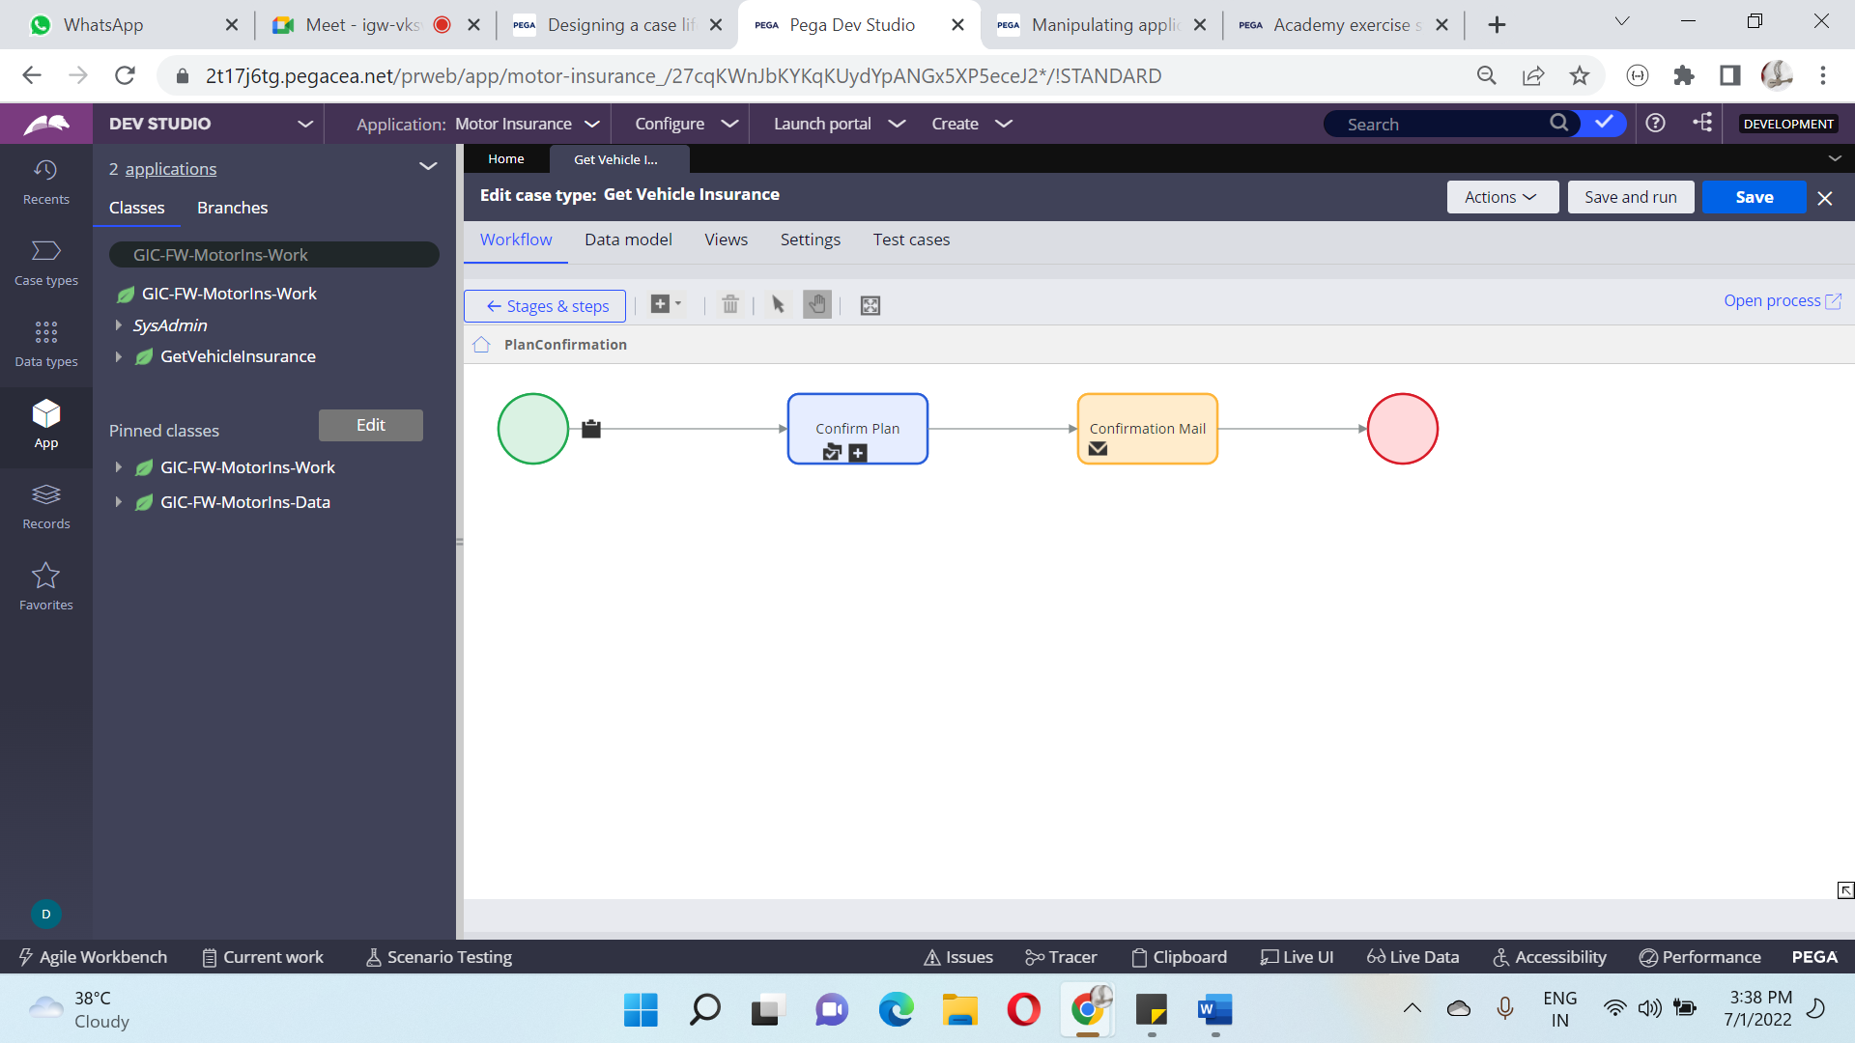

**Additional Information:**

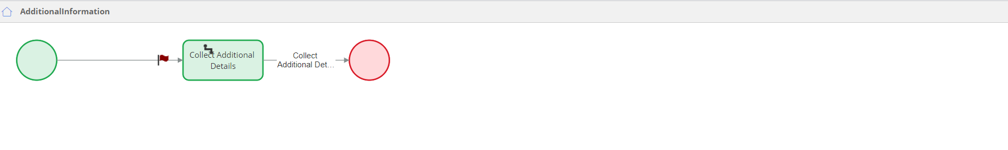

**Policy Payment:**

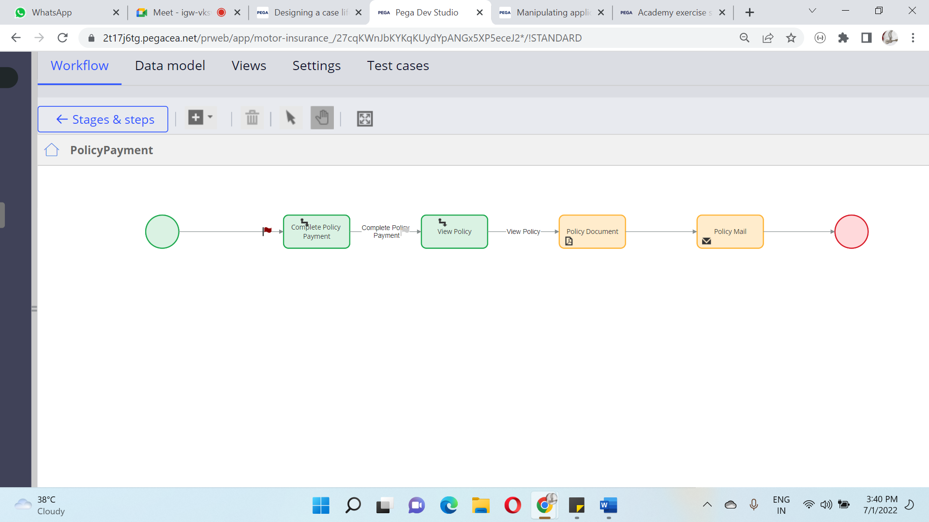

**Reject Plan:**

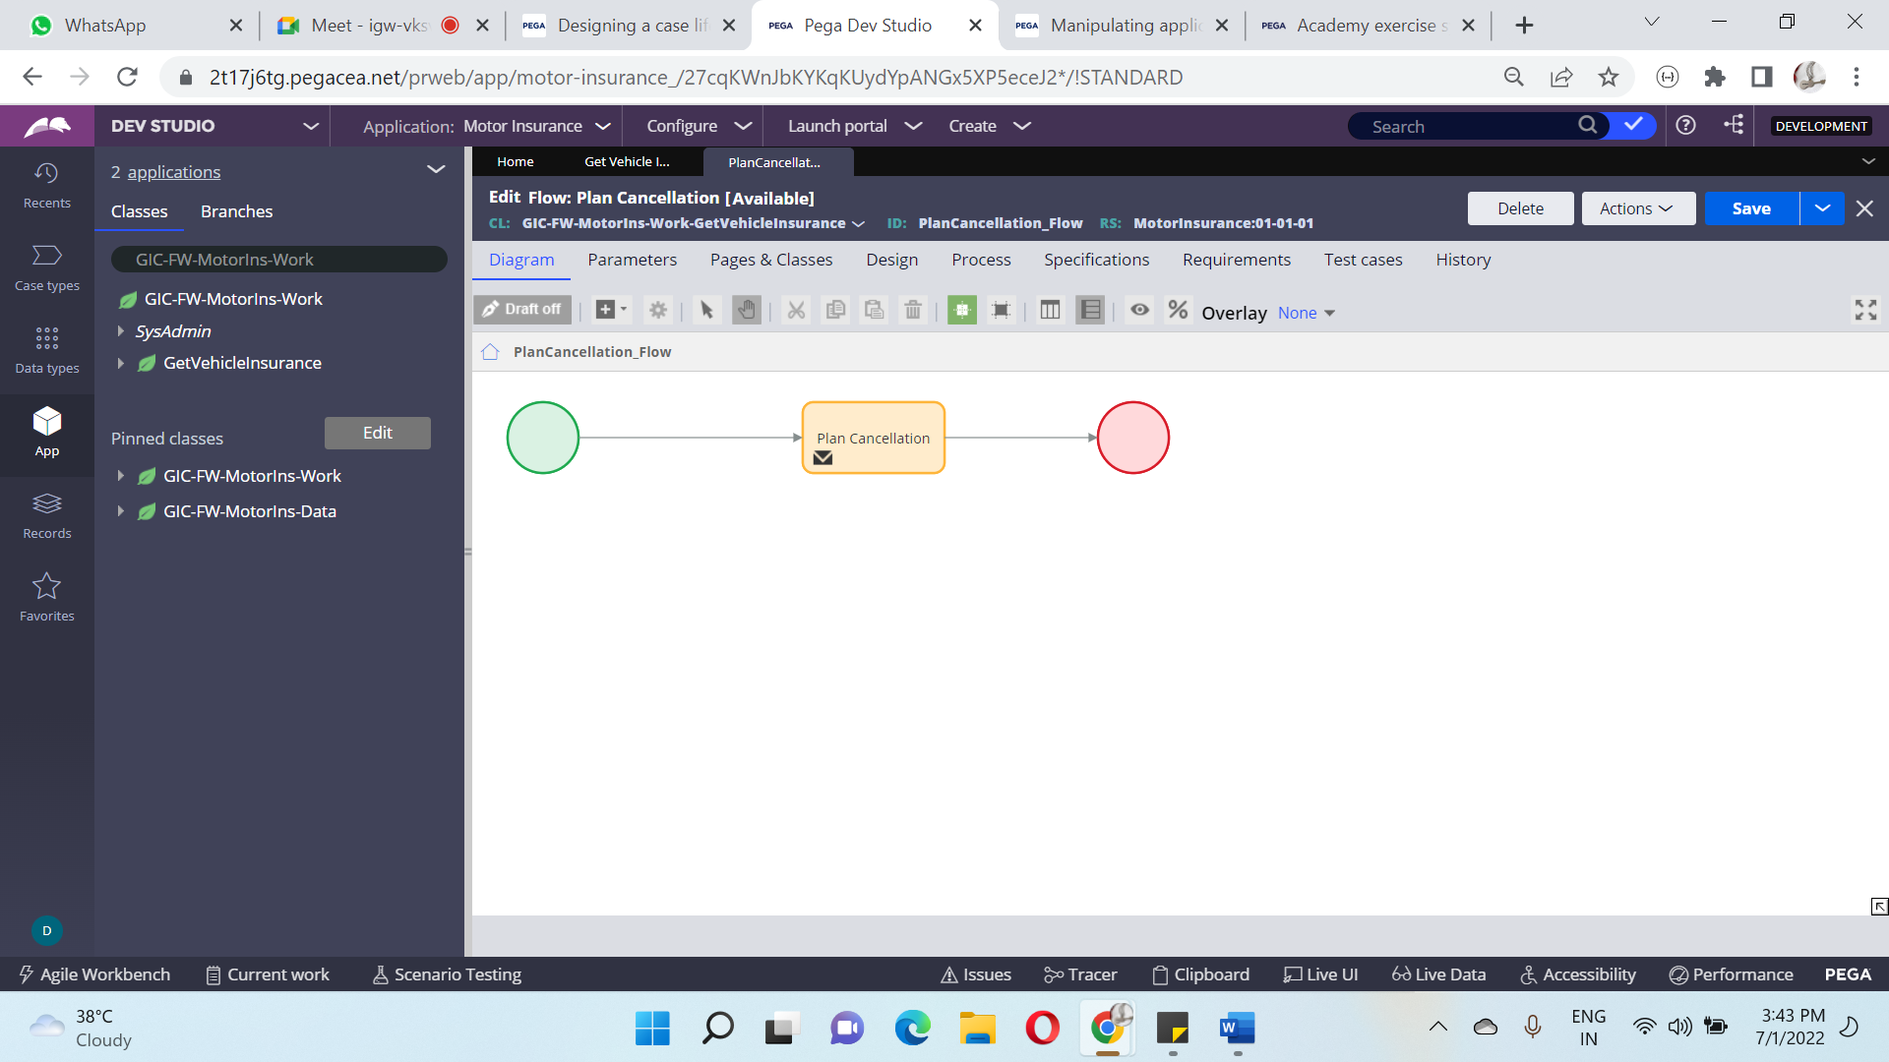**Reports:**

Quotation Status

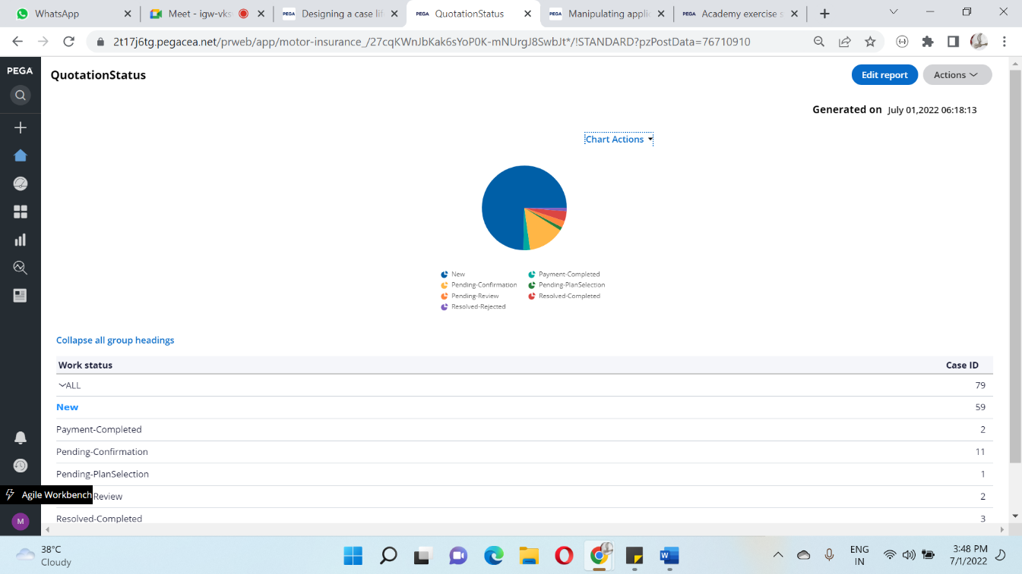

**Agent Portal:**

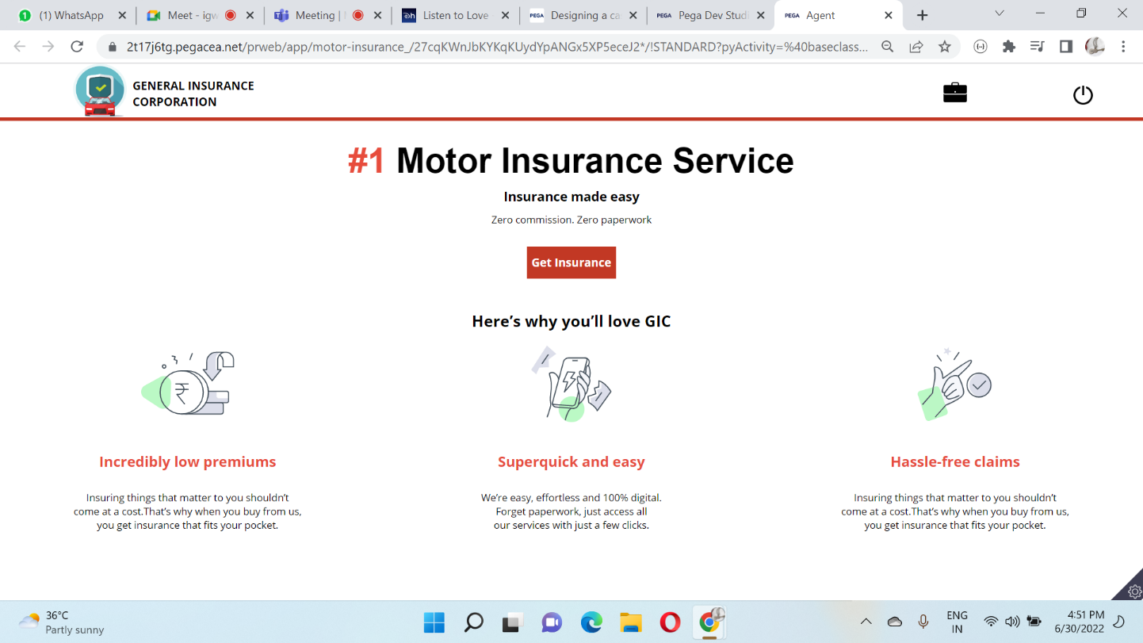

**Underwriter Portal:**

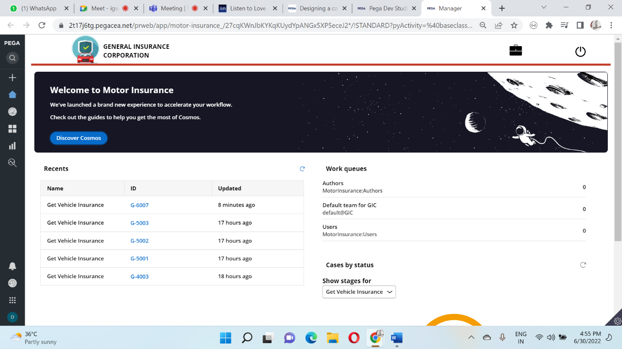

**Managers:**

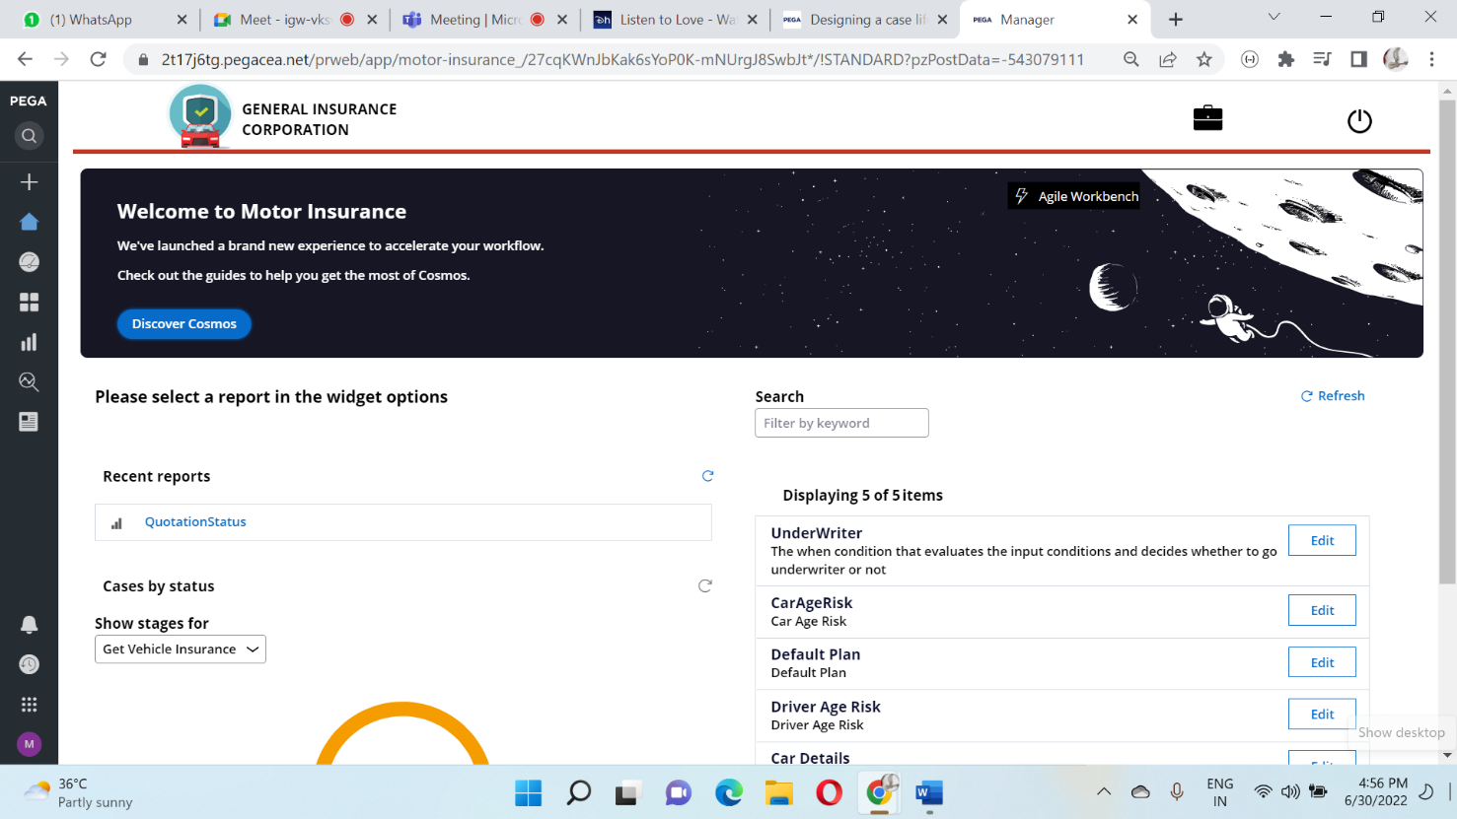

**Personas and Channels:**

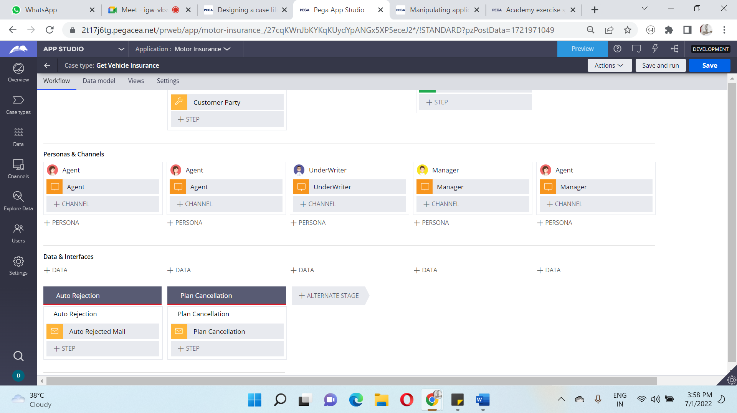

**Data and Interfaces:**

